**URL QUIZ GENERATOR DEMO**

**Step 1: Click on the create a new content to stat creating your quiz.**

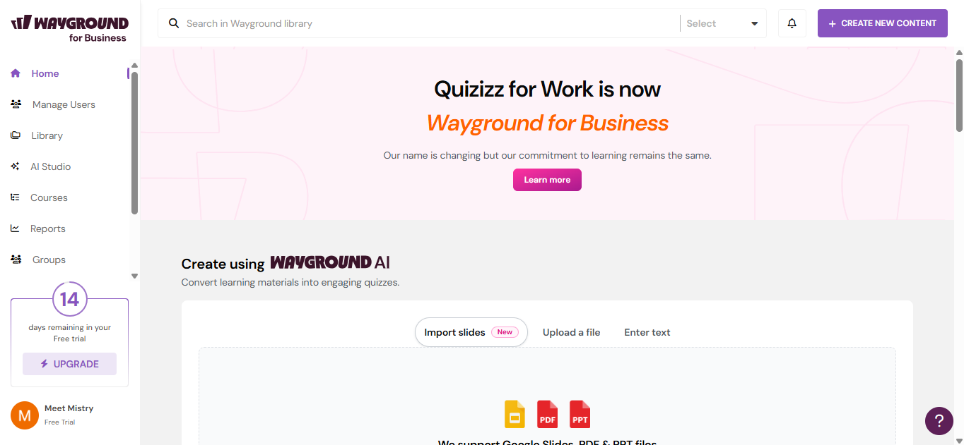

**Step 2: Select Create quiz using AI so that it helps you to generate a quiz better way**

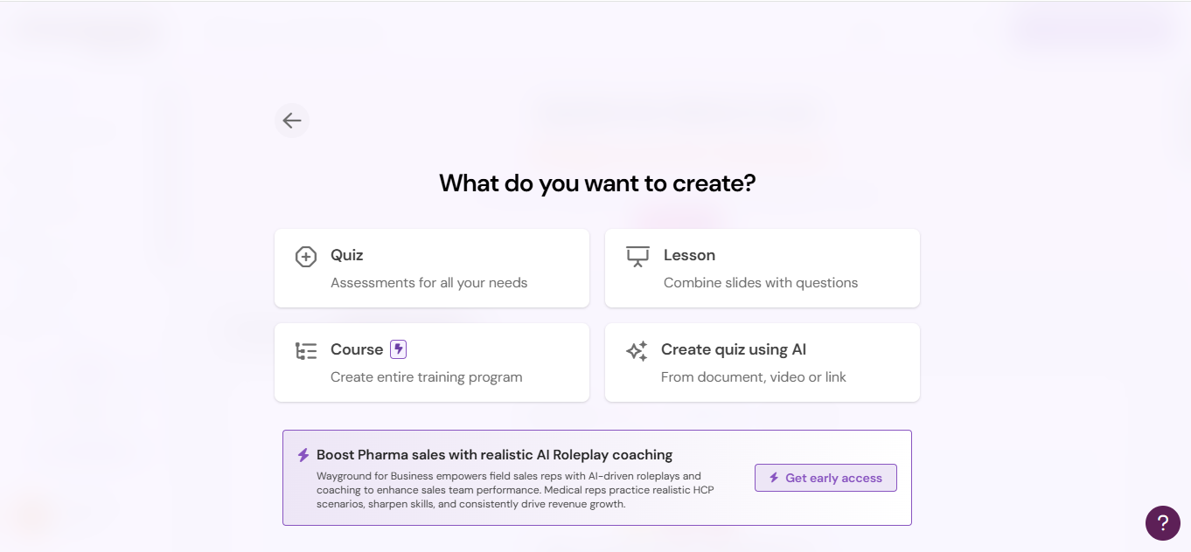

**Step 3: Choose Add any public or web link so quiz will be generated from the URL link**

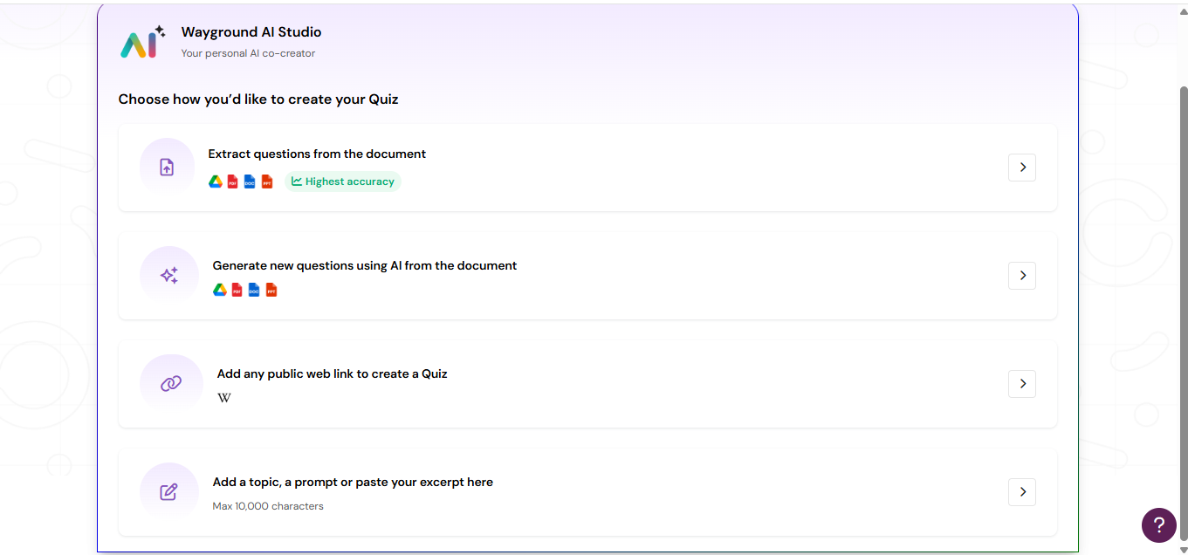

**Step 4: Paste Your URL in the field then click to the Add button to start with the follow up process.**

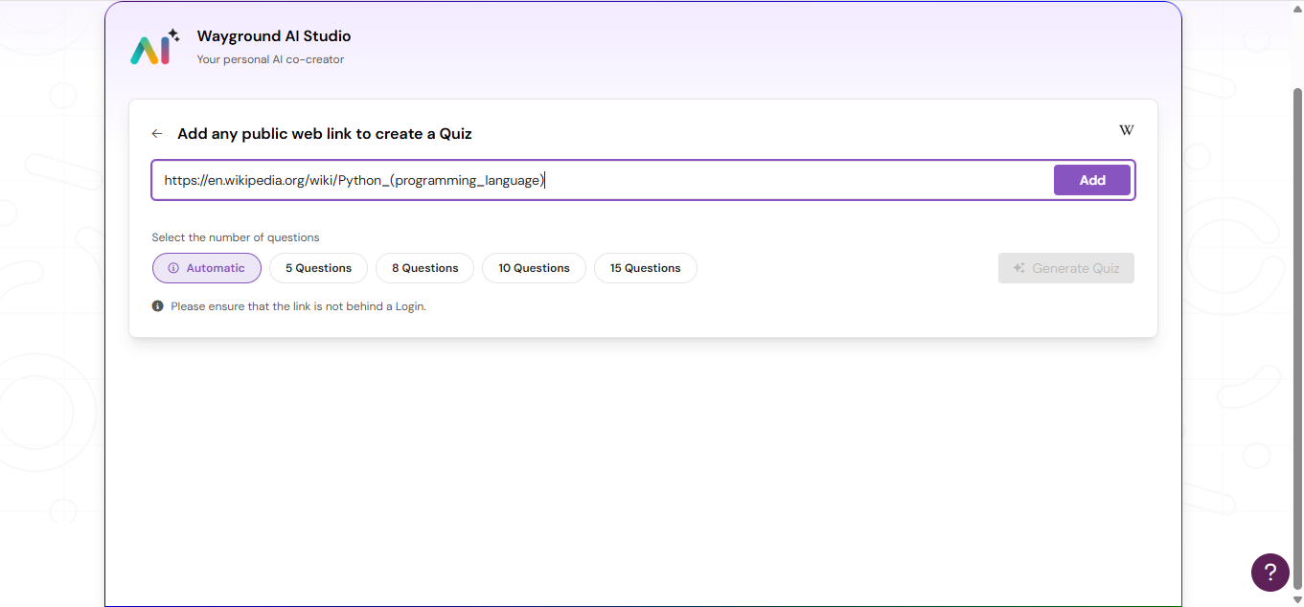

**Step 5: Your Quiz is now generating from the URL**

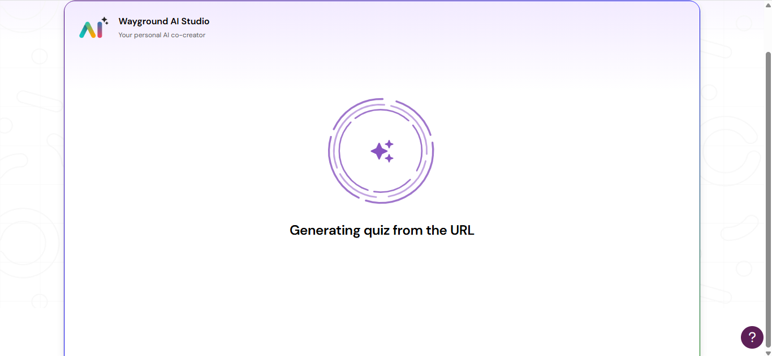

**Step 6: Here you can see your quiz is now generated with many editable options.**

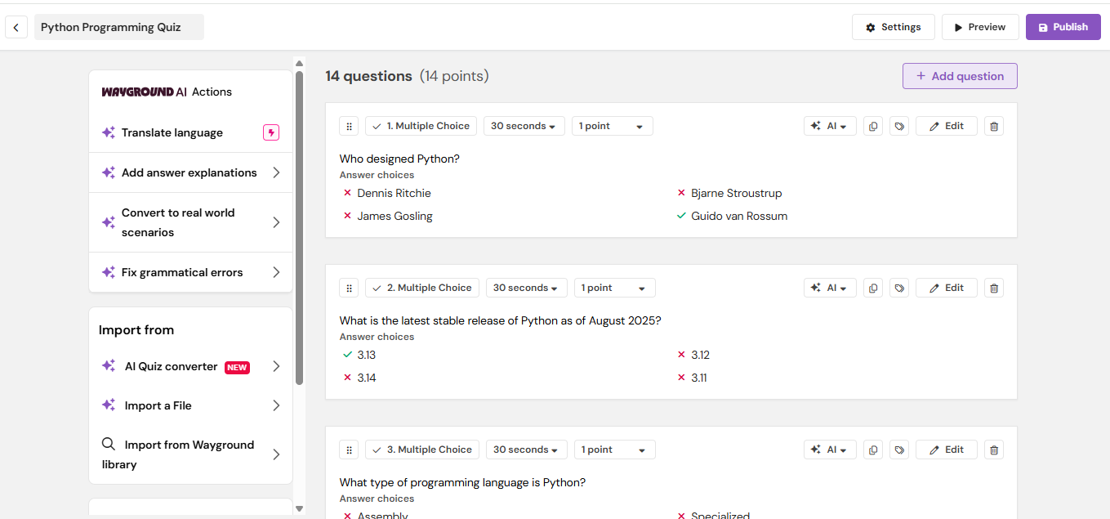

**Step 7: Here you can add any extra question if you want in your Quiz.** 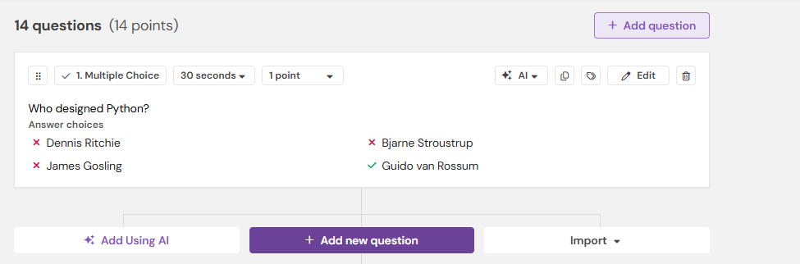

**Step 8: Here if you select Add answer explanations you can see all the brief explanations for all the correct answers that why is it correct like a way..**

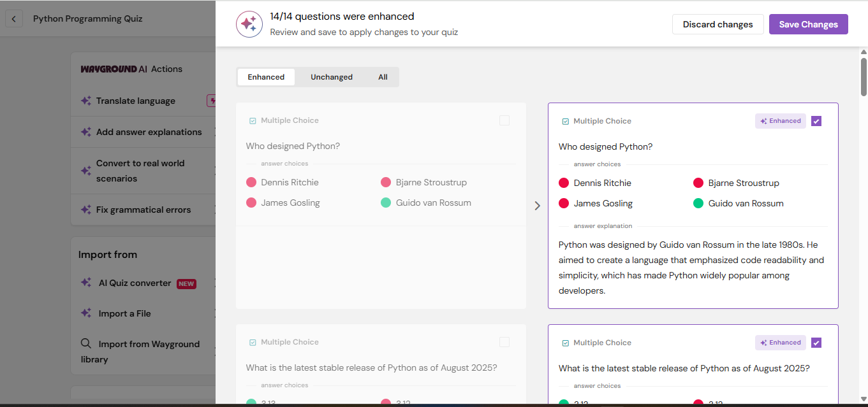

**Step 9: You can even set some points for every question, mark system and also put timings for each question**

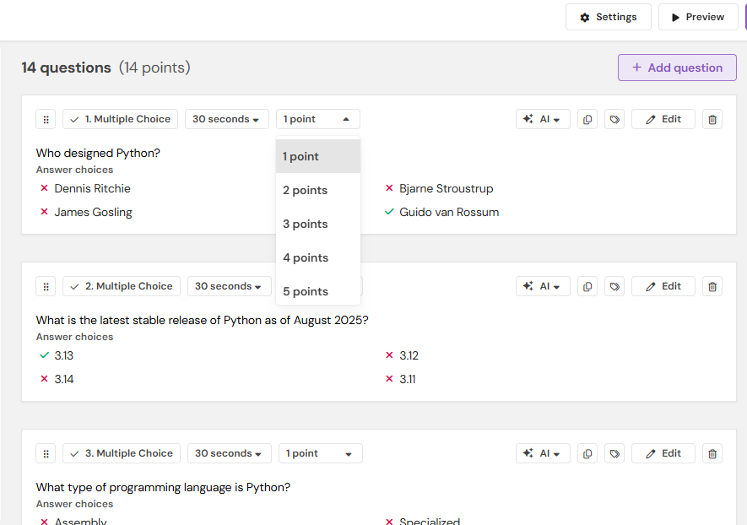

**Step 10: After clicking the Preview you will be able to see how your quiz will look like the UI design and everything after you publish.**

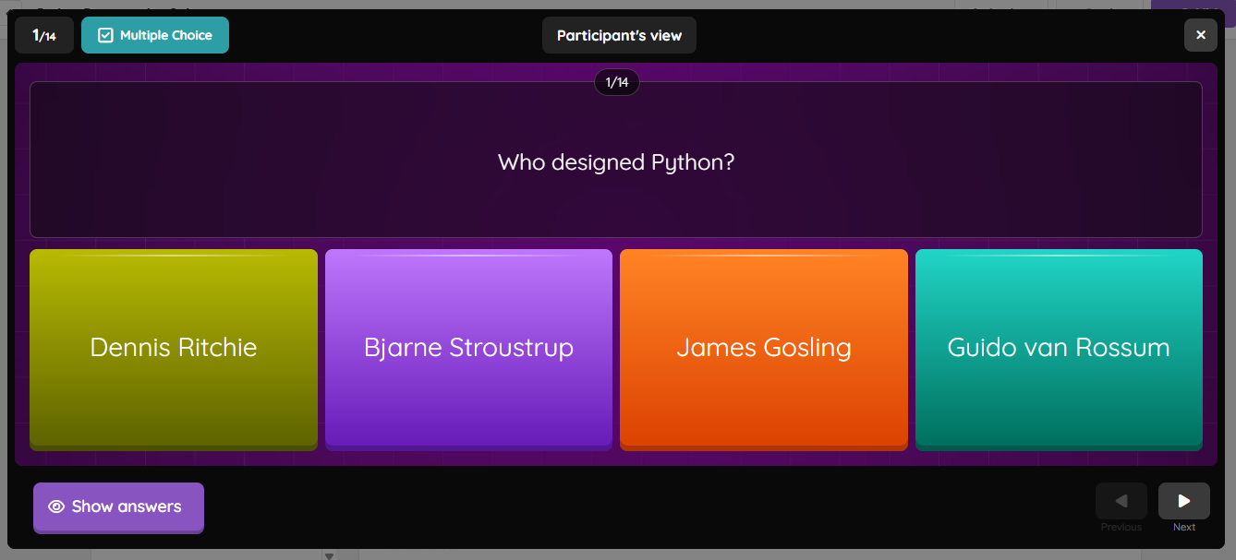

**Step 11: Now click on the Publish to start your Quiz...**

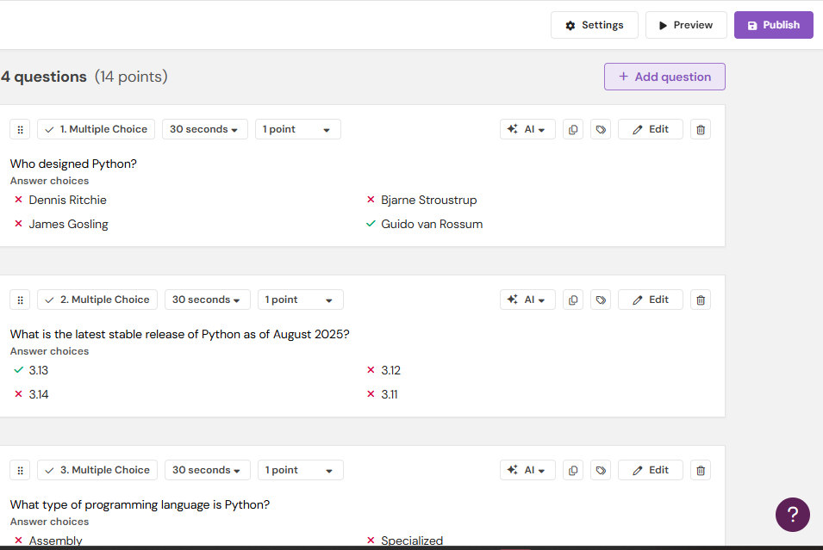

**Step12: Here you can see that there are many editable options where you can change the format of your quiz, as in instance, shuffling the questions/answers, allowing participants to view their answers after attempt, like a way...**

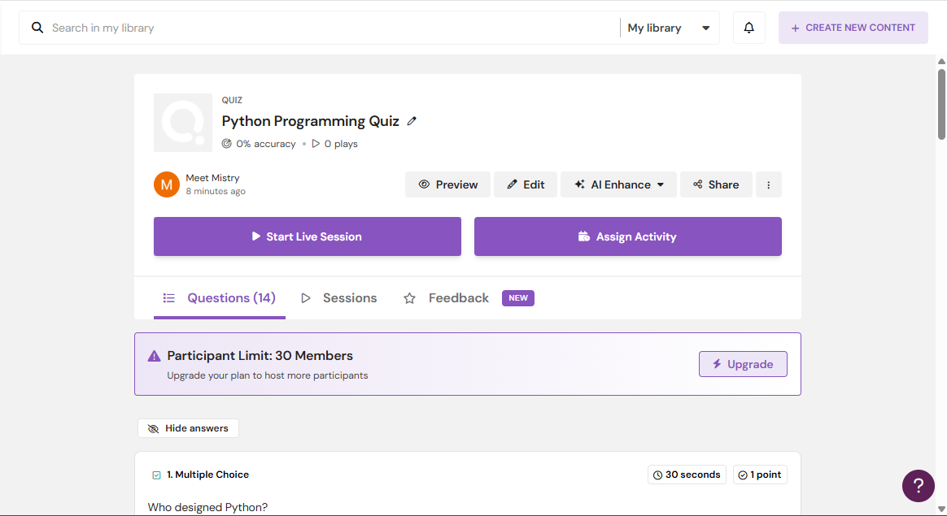

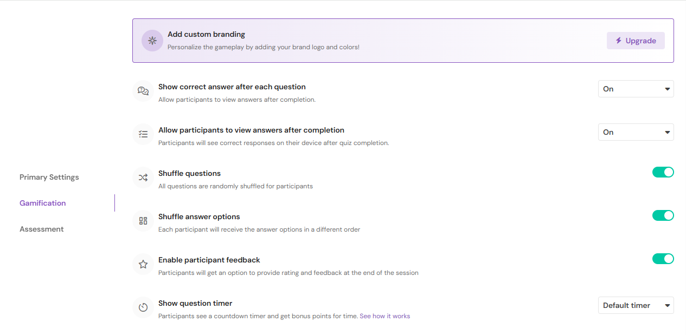

**Step 13: Now select to the Start live session to address your quiz to the audience**

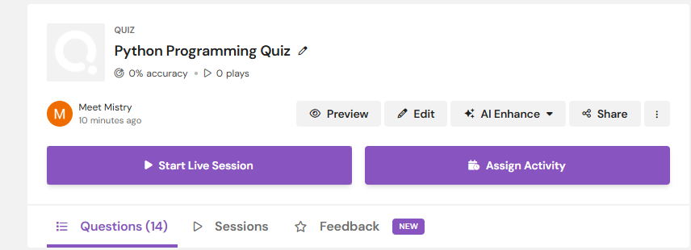

**Step 14: here audience can scan or write the Code to enter to the quiz**

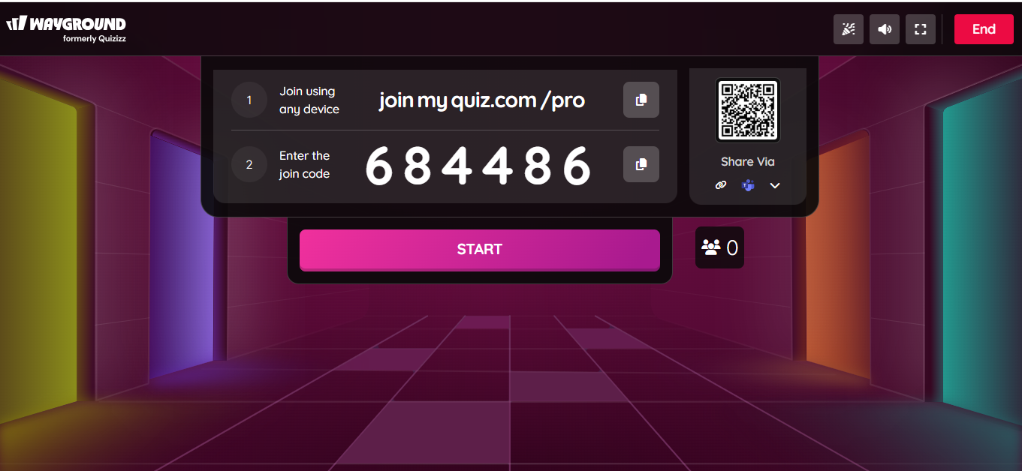

**Step 14: here you can see 3 participants have joined your quiz and we can even check their activity that whoever have made which question correct or incorrect.**

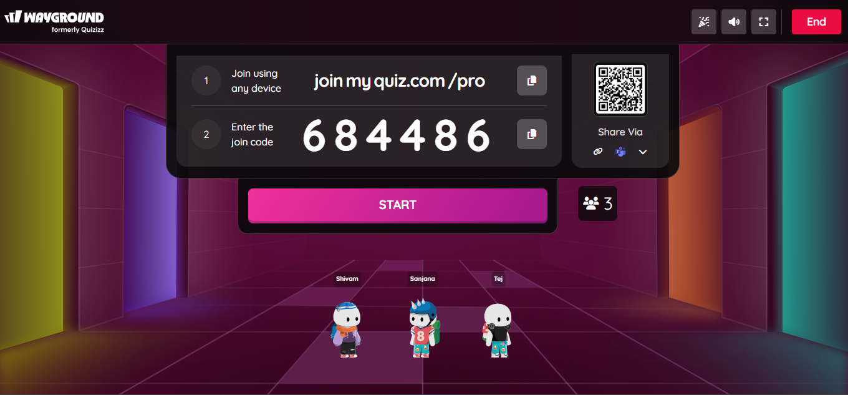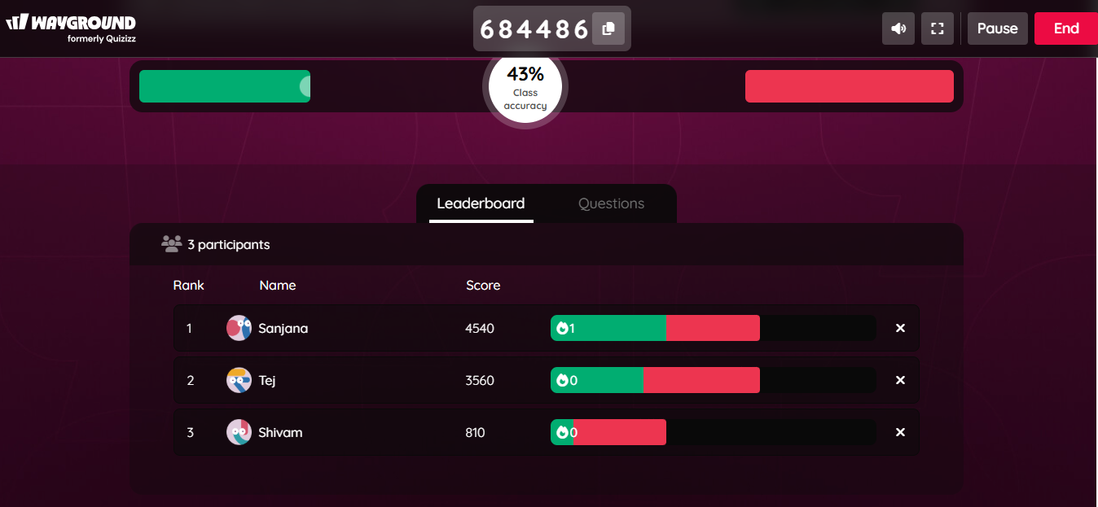

**Step 15: Here you can Preview the scored of your participants and their accuracy for being going to the correct answers**

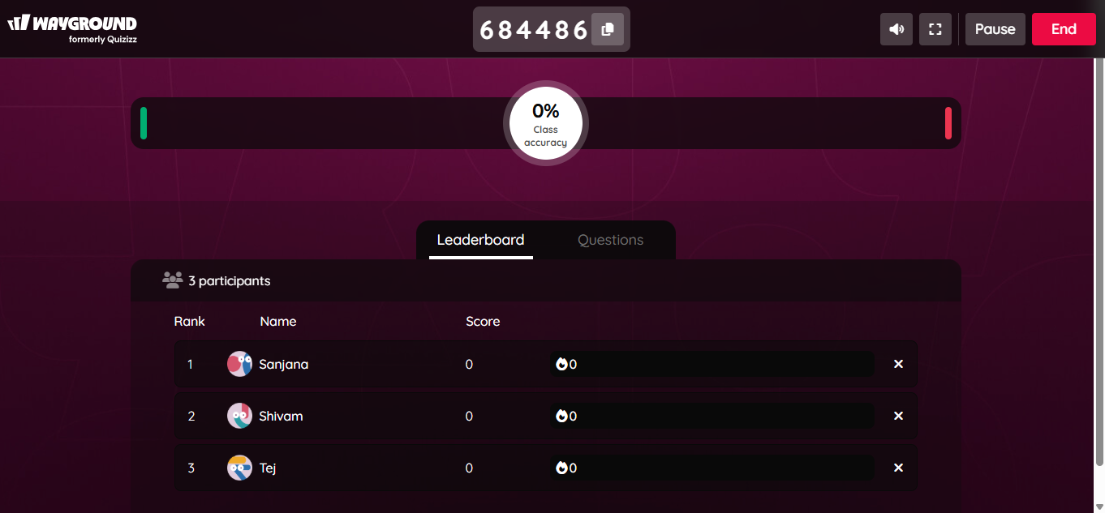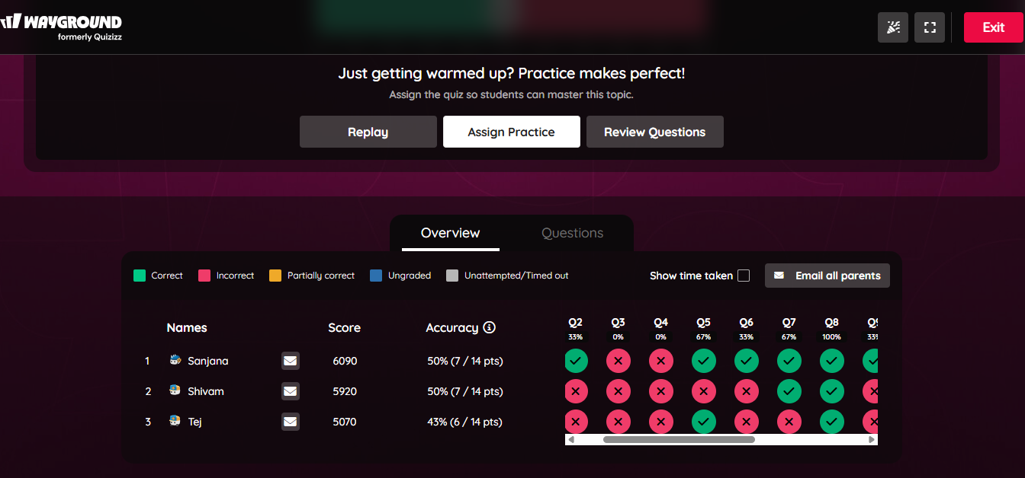

**Step 16: At last you can even check how much time an individual has taken to sum up single questions and hence, accordingly the can see their positions..**

